11 HUMAN BIOLOGY REPRODUCTION TEST
/60
Name: _____________________ Teacher:____________________ Date: ______

1) The milk let-down reflex is due to the action of which hormone?
- prolactin
- oxytocin
- prostaglandins
- oestrogen

2) Which sequence of development is the most likely for humans?
- grasps and shakes objects; eats unaided; picks up objects between thumb and forefinger.
- grasps and shakes objects; picks up objects between thumb and forefinger; walks.
- eats unaided; grasps and shakes objects; picks up objects between thumb and forefinger; walks
- eats unaided; grasps and shakes objects; picks up objects between thumb and forefinger.

4) Menarche is the
- end of the fertile period in women
- onset of puberty in girls
- onset of menstruation in girls
- rapid growth at puberty

5) Which of the following hormones causes development of secondary sexual characteristics in males?
- follicle stimulating hormone
- oestrogen
- testosterone
- Luteinizing hormone

6) The normal child will begin to walk at
- 2 years
- 15 months
- 3 months
- 2 ½ years

7) Which statement is true?

a) Where the unbiblical cord attaches to the chorion, the placenta develops
b) The upper most layer of the embryo is the endoderm
c) The embryonic disc separates the chorion cavity and the yolk sac
d) The ectoderm will develop into the gut, trachea, lungs and liver.

8) The diagram below shows the cervix almost completely opened and the amnion is bulging in the front of the head this is:
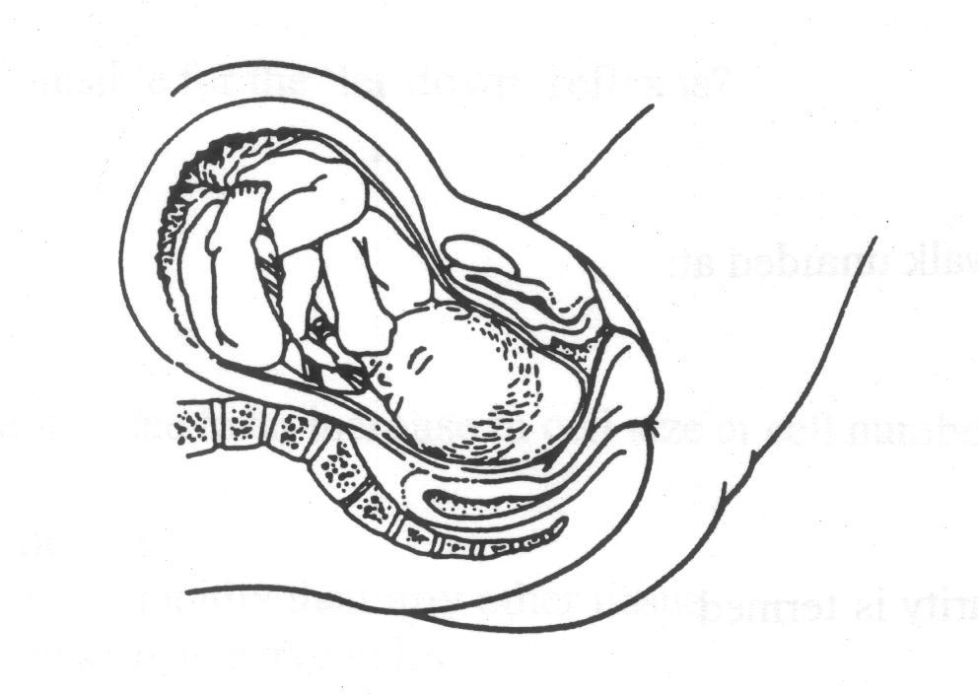

a) early in the first stage of labour
b) early in the second stage of labour
c) late in the first stage of labour
d) late in the second stage of labour

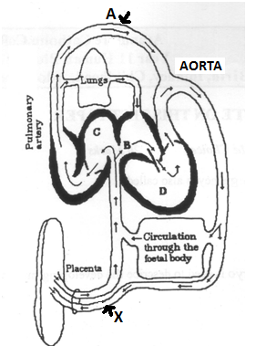

9) Consider the diagram on the right.

Label A and X represent:
a) ductus arteriosus and umbilical artery
b) umbilical cord and umbilical artery
c) umbilical cord and umbilical vein
d) inferior vena cava and umbilical vein

10) Which of the following substances are received by the pregnant mother from the foetus?

a) Urea and Carbon dioxide
b) Carbon dioxide and glucose
c) Urea and amino acids
d) Amino acids and glucose

11) At what stage should a baby be able to crawl to another person?

a) 1 – 3 months
b) 4 – 5 months
c) 6 – 9 months
d) 10-12 months

12) The ovarian follicle secretes the hormone:

- oestrogen
- follicle stimulating hormone
- progesterone
- luteinizing hormone

- Which of the following pairs of sexually transmitted diseases are caused by viruses and are therefore difficult to treat?

- Herpes and syphilis
- Acquired immune deficiency syndrome and herpes
- Syphilis and gonorrhoea
- Acquired immune deficiency syndrome and gonorrhea

14) In treating infertile women, sometimes eggs are collected, fertilised in a dish in a laboratory and transferred to the uterine tubes at the one-cell stage, requiring two operations 24hours apart. This method is commonly known as:

a) ICSI
b) TET
c) ZIFT
d) GIFT

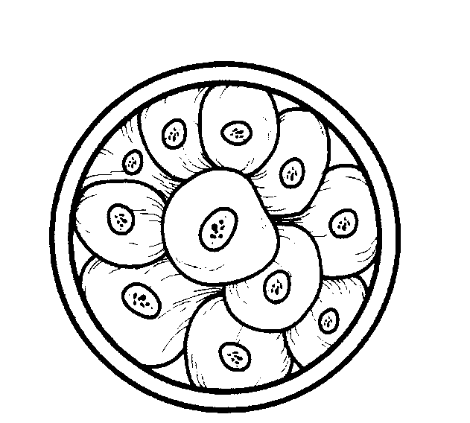
15) The stage of development illustrated on the right is called:
a) morula
b) zygote
c) embryo
d) blastula

SHORT ANSWERS

- What secondary sexual characteristics would a physically mature adolescent present? List for both males and females. (6 marks)

______________________________________________________________________________
______________________________________________________________________________
______________________________________________________________________________
______________________________________________________________________________
______________________________________________________________________________

- Summarise the differences and similarities between spermatogenesis and oogenesis in the table below. (4 marks)

Similarities | Differences

- What are the three primary germ layers of embryonic tissue and name two features which develop from each.
(6 marks)
______________________________________________________________________________________________________________________________________________________________________________________________________________________________________________________________________________________________________________________________________________________________

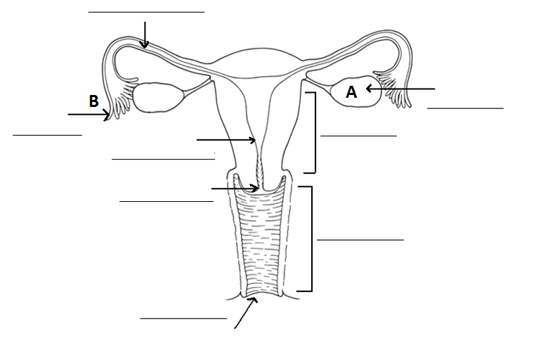
3. Label the diagram below. (4 marks)
11
3b. What is the function of structure A.
____________________________________________________________________________________________________________________________________________
3c. What is the function of structure B.
____________________________________________________________________________________________________________________________________________

4. Label the diagram below. (5 marks)
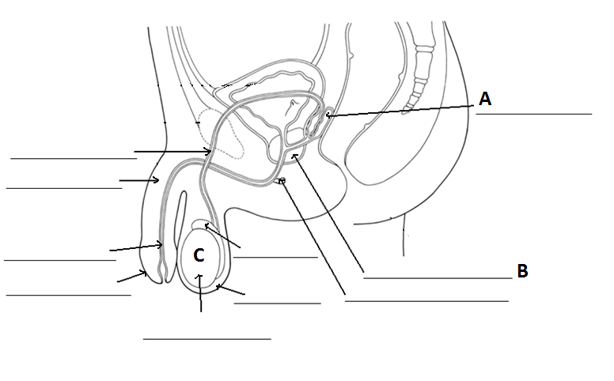
11

4b. What is the function of structure A. (1 mark)
____________________________________________________________________________________________________________________________________________
4c. What is the function of structure B. ( 1 mark)
____________________________________________________________________________________________________________________________________________
4d. What is the function of structure C. (1 mark)

. Answer the following questions using the table.
 | Time  Weeks | Developmental stages
FIRST TRIMESTER | 0 | Fertilisation
FIRST TRIMESTER | 1 | Embryo reaches uterus. Implantation
FIRST TRIMESTER | 2 | Flat, 2-layered disc. Ectoderm and endoderm. Sac-like digestive tract, no mouth or anus.  Umbilical cord forming.
FIRST TRIMESTER | 3 | 3 layers present – ectoderm, mesoderm, endoderm. Beginnings of skeletal/nervous systems.
FIRST TRIMESTER | 4 | Simple 2-chambered heart, tail, gill pouches, limb buds. Muscular system forming, neural tube  closing to form Spinal cord and brain.
FIRST TRIMESTER | 5 | Mouth, eyes, webbed fingers and toes, lungs and regions of digestive canal form
FIRST TRIMESTER | 6 | Cerebral hemispheres, face, ears form
FIRST TRIMESTER | 7 | Eyes open, tail disappears.
FIRST TRIMESTER | 8 | All major systems formed. Now called a foetus. Ossification (replacing cartilage by bone)  begins. Makes small movements, not yet felt by mother.
FIRST TRIMESTER | 9
FIRST TRIMESTER | 12 | External genital organs developed
SECOND  TRIMESTER | 16 | ‘Quickening’ (movement) felt by mother. Heart can be heard.
SECOND  TRIMESTER | 21 | Heart rate 140 beats/min. Head hair appears. Skin glands produce white paste to protect  delicate skin. Sleeps and wakes.
SECOND  TRIMESTER | 25 | Vigorous movements.
THIRD  TRIMESTER | 30 | Testes descend. Fat deposited. Fine hair (lanugo) covers head and body.
THIRD  TRIMESTER | 34 | Lanugo drops away. Takes up birth position. Head down usually.
THIRD  TRIMESTER | 38 | Full term. Skin covered with cheese-like vernix caseosa. Uterus has moved down in pelvis.  Baby’s pituitary signals for birth to begin.

a. During what stage is the embryo/foetus the most vulnerable to adverse effects?
____________________________________________________________________________________________________
b. During what stage/week does the embryo’s tail disappear?
____________________________________________________________________________________________________
c. During what stage/week do the fingers and toes form?
____________________________________________________________________________________________________

Describe one technique used for detecting birth defects.
____________________________________________________________________________________________________
______________________________________________________________________________

1. Explain three reasons why breast-feeding is good for the baby and mother. (3 marks)
______________________________________________________________________________
______________________________________________________________________________
______________________________________________________________________________
______________________________________________________________________________
______________________________________________________________________________

Label the diagram below.

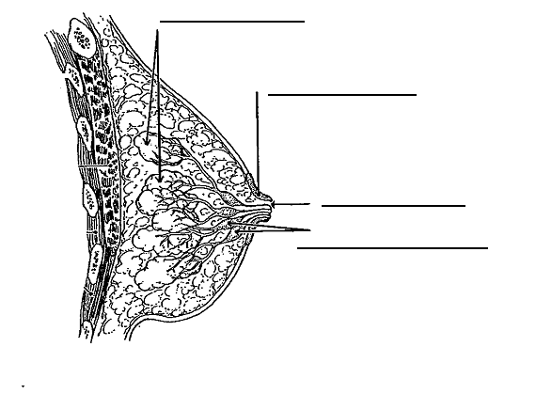
Fill in the table below (6 marks)
Method of birth control | Advantages | Disadvantages
Condom
Combined pill
Vasectomy

Choose ONE of the following sexually transmitted infections and describe its cause, symptoms and treatment.
Syphilis
Gonorrhoea
Chlamydia
______________________________________________________________________________
______________________________________________________________________________
______________________________________________________________________________
______________________________________________________________________________
______________________________________________________________________________

Pregnant mother – label diagram on page 164
Menstrual cycle

